Papers written by
Australian Maths Software

SEMESTER ONE
MATHEMATICS APPLICATIONS
REVISION 1

UNIT 3

2016

SOLUTIONS

SECTION ONE
1. (5 marks)
(a) A simple graph contains no loops or multiple edges. ✓ (2)
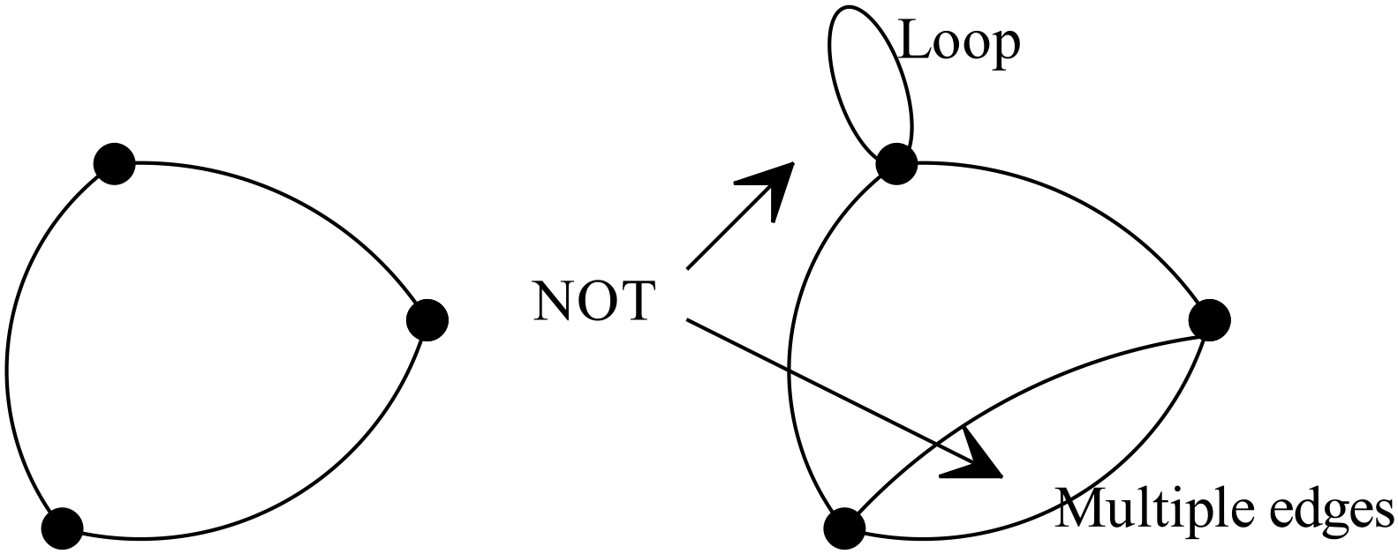
✓

(b) (i) A complete graph is a simple graph in which every pair of vertices is connected.
In the diagram there is a pair of vertices that are not connected so not
complete. ✓ (1)

(ii)
✓

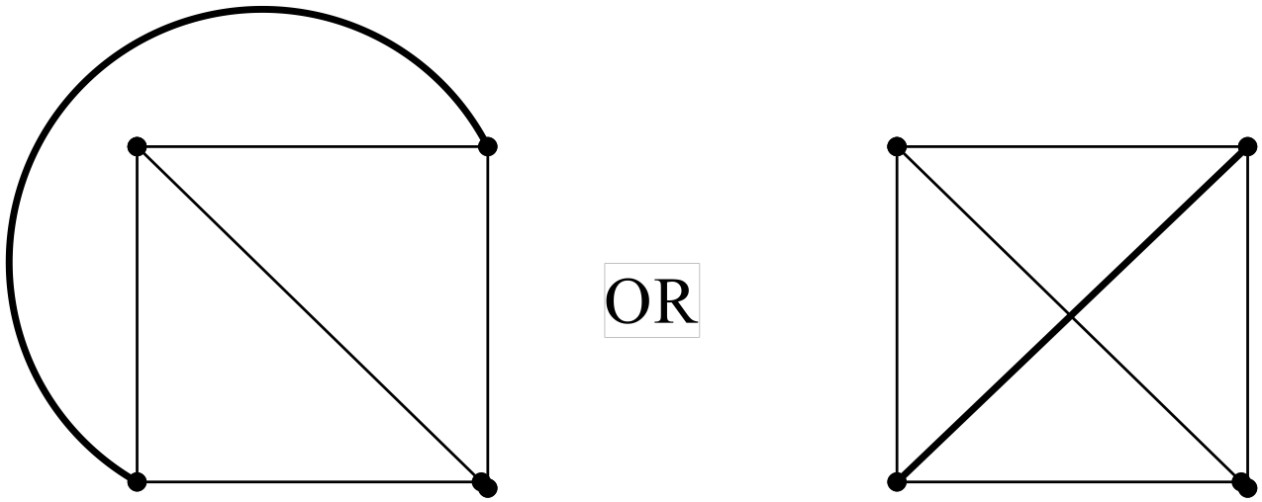
✓

(1)
(c) Subgraph.
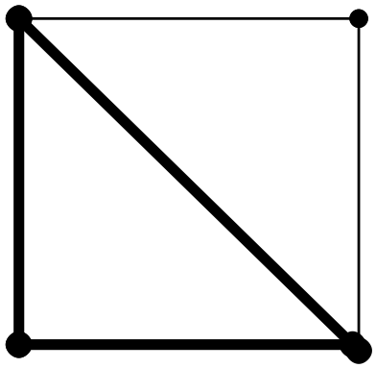
Answers will vary (1)
2. (7 marks)
✓

(a) Calculate the equation of the regression line and plot it on the graph
Check the residuals with respect to the regression line.
If the residuals are randomly distributed about the regression line,
✓

then a linear fit is appropriate.
In the data graphed, it will be found that the points will be mostly below the
regression line on the left and right sides and above the regression line in the
centre. This suggests a parabolic fit is better.
✓

The lack of randomness of the residuals suggest a linear fit is not appropriate.
(3)

(b) The headmaster can ask his students to tick their choice of
A “a roof over their lunch area”

OR
✓✓

B “an extension to their lunch area but with no roof”
The data can be collected in year groups so the headmaster has a breakdown of the
✓

opinion of those in each year.
✓

The data can then be put into a two way table showing the preferences of the
students.

Anything sensible (4)

3. (7 marks)

(a) Flights between cities OR Telephone calls made between cities on a certain day etc
✓✓
Answers will vary (2)
(b) Hobby groups OR Friendship groups ✓✓

Answers will vary (2)

(c)
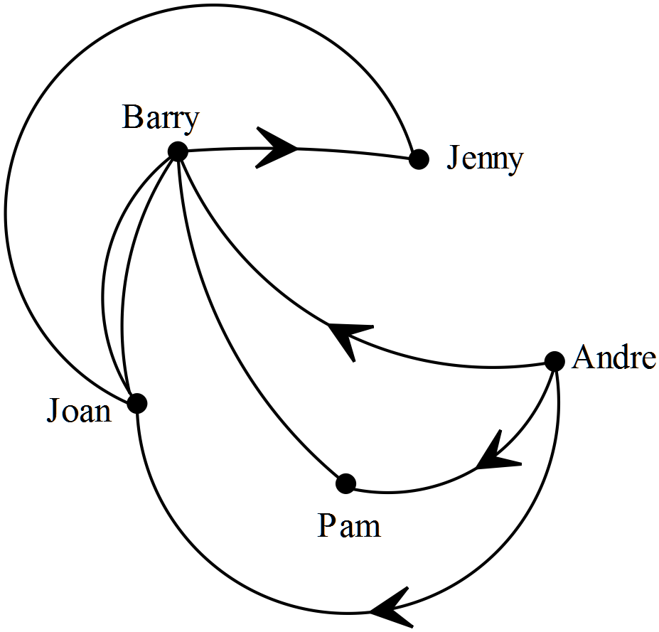✓✓✓
(3)
-1error

4. (8 marks)
(a) 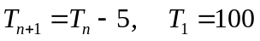 ✓✓ (2)
✓✓✓ -1/error

(b) (i) 10 000, 11 000, 12 100 (3)
(ii) 20, 30, 50 ✓✓✓ -1/error (3)

5. (3 marks)
This is a spurious relationship.
There are other factors that can decrease the divorce rate over the years and other factors
again that affect the consumption of margarine.
Anything sensible ✓✓✓ (3)

6. (11 marks)
(a) (i) A planar graph is one that can be drawn in the plane so that no edges cross.
✓ (1)
(ii)
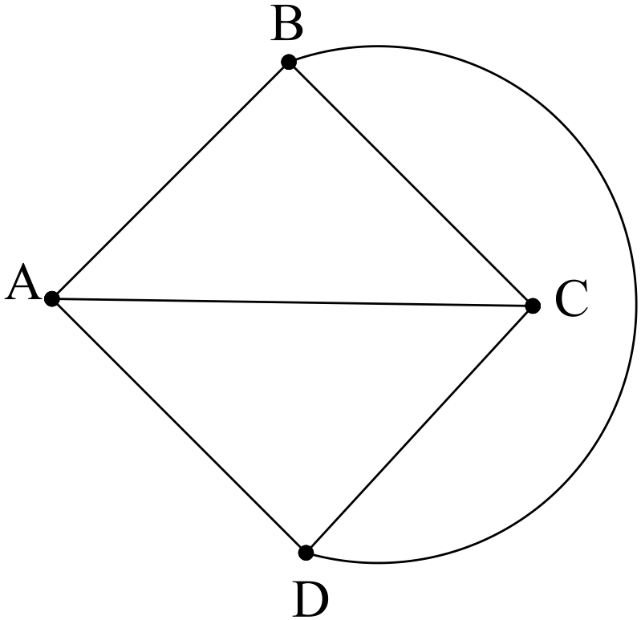
✓✓ (2)
(b) (i)
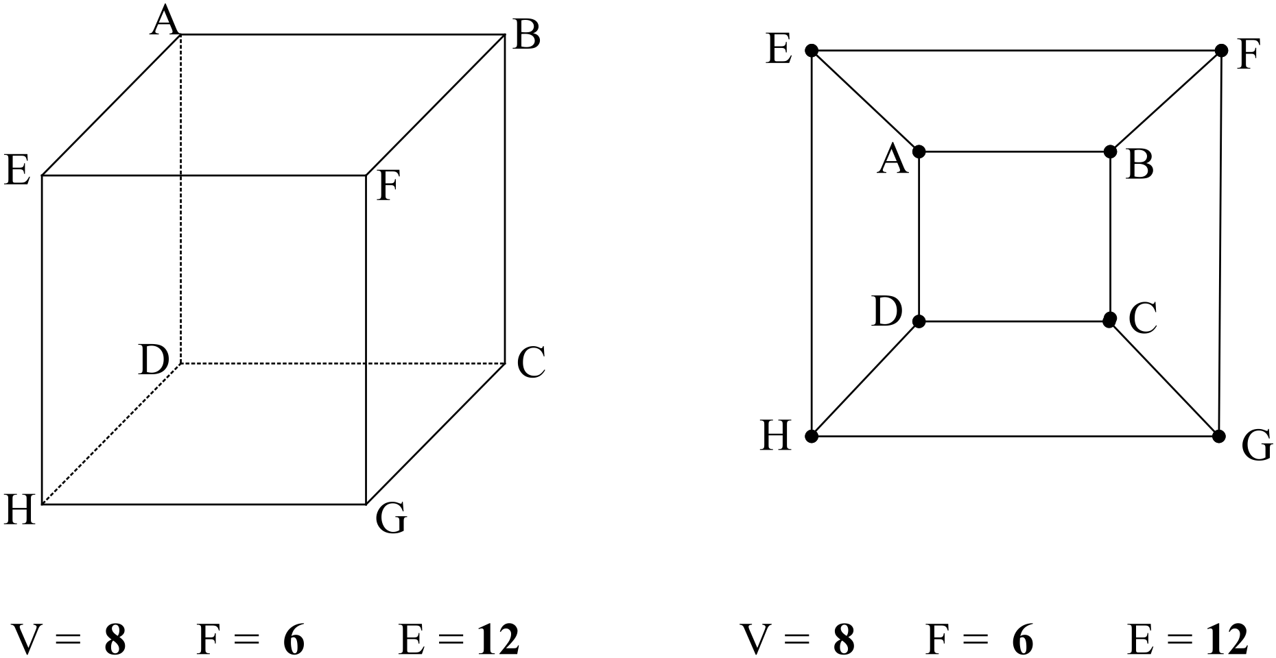
✓✓✓ (3)
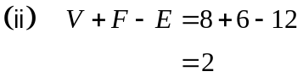 ✓✓
Euler’s law works so the hexagon can be drawn as a planar graph and
represents the same information. ✓ (3)
(c)
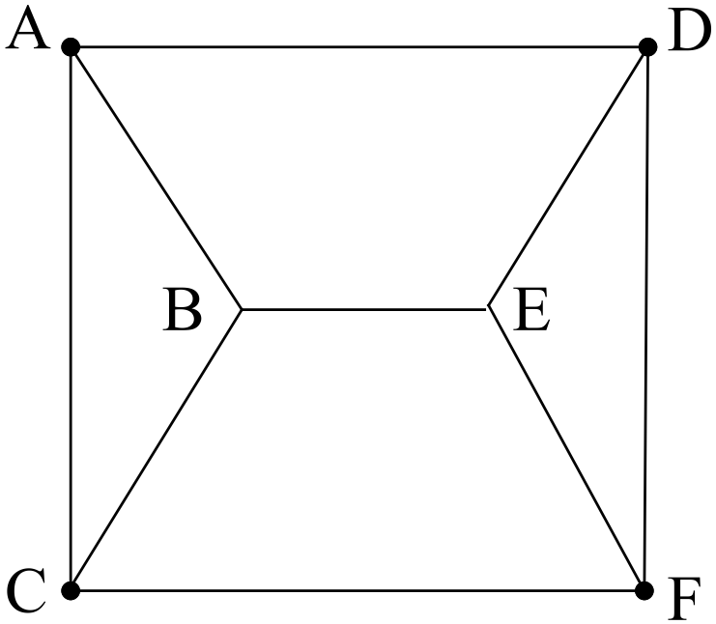
✓✓ (2)
7. (11 marks)

(a) (i)
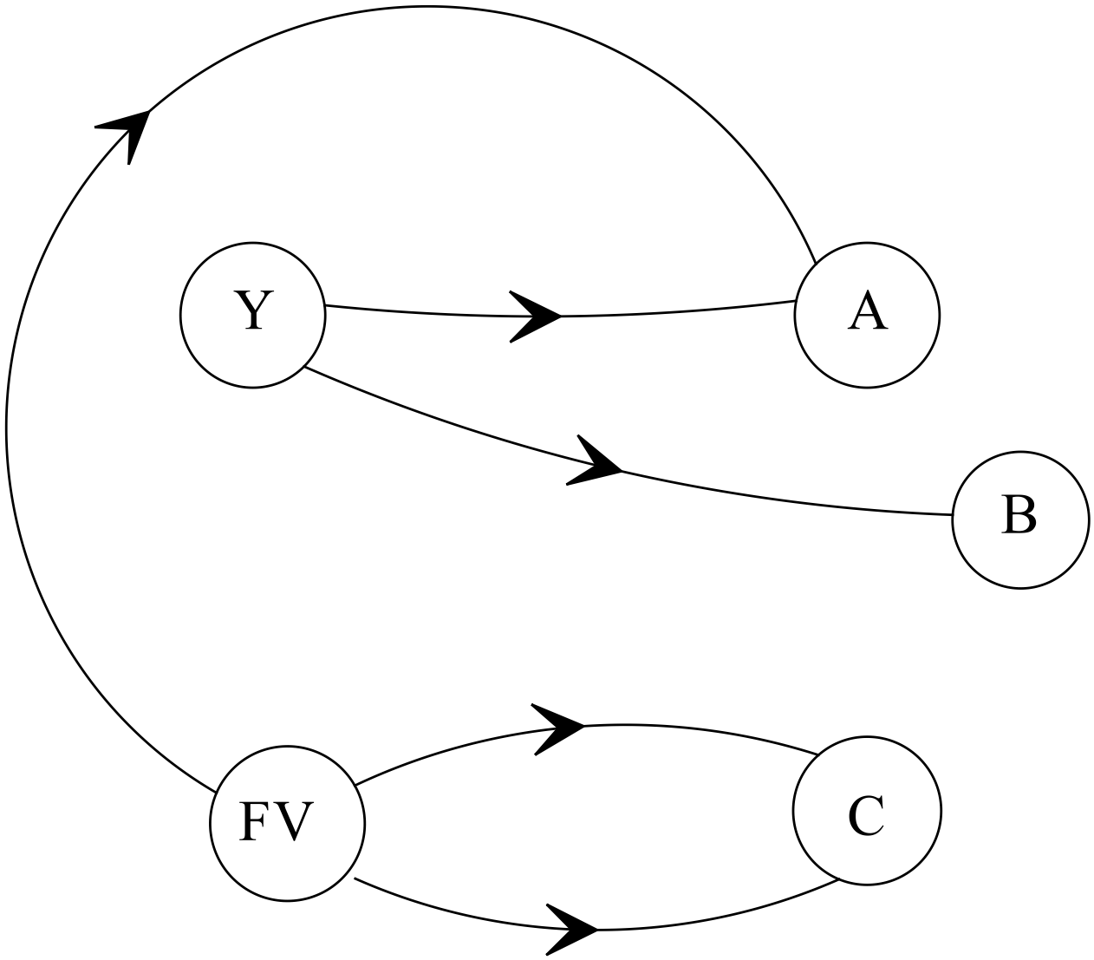
✓✓✓ -1/error

(3)
(ii)
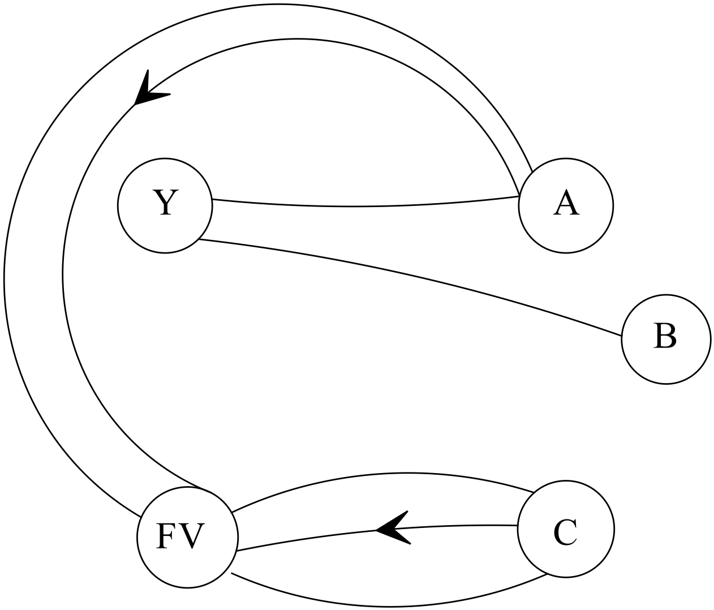
✓✓ -1/error

(2)
(iii) The graph is an example of a bipartite graph because there are two distinct sets
that graph to each other and not to elements within either sets themselves.
✓✓ (2)

(b) 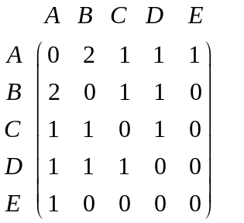✓✓✓✓ -1/error (4)

END OF SECTION ONE
SECTION TWO

8. (4 marks)
✓
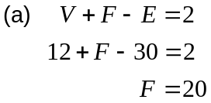
✓
(2)
(b) (E) ✓
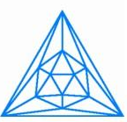
Chosen as it has the same number of vertices, edges and faces as the icosahedron. ✓ (2)
9. (9 marks)
(a)
n | Total number of beanies knitted at end of week n
1 | 40
2 | 52
3 | 64
4 | 76

(b) 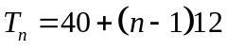 ✓
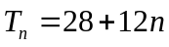 ✓ (2)
(c) 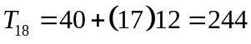 ✓✓ (2)

(d) 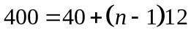 ✓
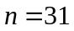 ✓ (2)
10. (8 marks)
✓

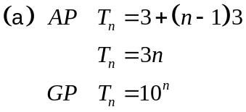
✓✓

✓

(4)
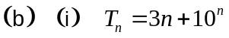 ✓✓ (2)
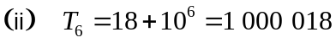 ✓✓ (2)

11. (12 marks)
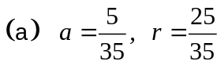 ✓
There is a first term and the common ratio exists, so a GP is formed. (2)
✓

(b) P(Jack wins on his fifth roll)
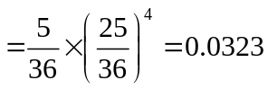 (3)
✓ ✓✓

(c) P(Jill wins on her second roll)
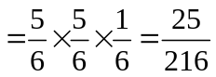 (3)
✓ ✓ ✓

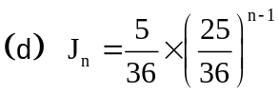 ✓✓ (2)

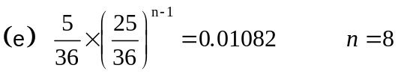 (2)
✓ ✓

12. (9 marks)
(a) (i)
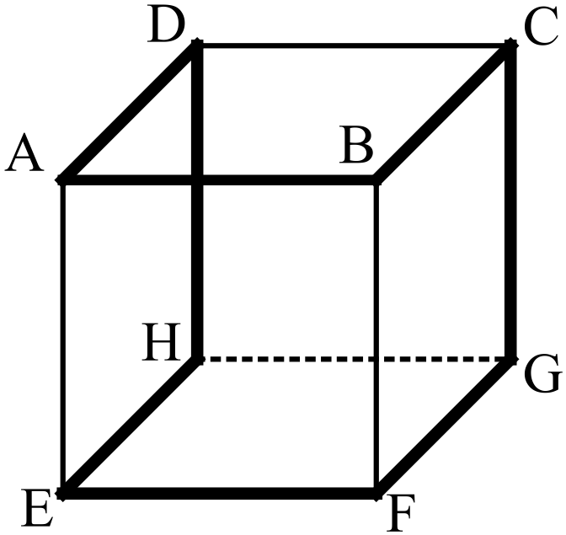
✓✓

✓
ADHEFGCBA (3)

NB A Hamiltonian Circuit is a circuit that visits every vertex exactly once.
(ii) The cube does not represent a three dimensional Eulerian graph because
each edge cannot be visited exactly once.
✓

To do this there are either no odd nodes or exactly two odd nodes.
Here, every node is odd. There are 8 odd nodes. (2)
✓

(b) Yes, this is feasible as all vertices are even.
✓✓
✓

ABCDEGFA Answers will vary
✓✓

13. (4 marks)

(a) (i) 4 ✓ (1)
(ii) 10 ✓ (1)

(b) Eulerian graph because each edge can be visited exactly once ✓
( if you start and end at D and E)
Bipartite graph as A, B and C only map to D and F, not to each other. ✓ (2)

14. (4 marks)

(a) ABDIJL ✓✓ (2)

(b) Maximum length is now 33 metres and was 31 metres ✓
so 2 metres longer. ✓ (2)

15. (7 marks)

(a)
Year | The expected number of employees
2015 | 400
2016 | 420
2017 | 441
✓✓ (2)

(b) 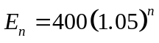 ✓✓ where is the number of years after 2015 (2)

(c)
Year | The expected number of employees
2015 | 400
2016 | 410
2017 | 420.5

Accept either 420 or 421 ✓✓ (2)

(d) Yes, the number of employees is still growing each year. ✓ (2)

16. (11 marks)
(a) (i)
2015-16 | Estimated Population | GST distribution to the states in $million | GST received per capita per state
NSW | 7 682 441 | $17 345 | $2 258
VIC | 6 001 823 | $12 755 | $2 125
QLD | 4 847 938 | $12 990 | $2 679
WA | 2 686 269 | $1 944 | $724
SA | 1 708 718 | $5 518 | $3 229
TAS | 517 161 | $2 236 | $4 324
ACT | 394 899 | $1 071 | $2 712
NT | 251 940 | $3 335 | $13 237

✓✓✓✓ (4)

(ii) On face value, no, not fair, but unemployment, living conditions etc need to be
taken into account. ✓ Accept anything sensible. (1)
(b) (i) 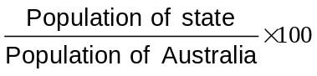 ✓✓ (2)
(ii) 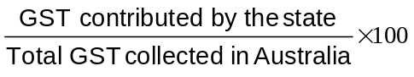 ✓✓ (2)

(iii) The chart in (a) (i) shows the GST per person per state. The calculation is
based on the population per state. ✓
The chart in (b) compares the percentage of the population of the state to the
percentage of total GST the state receives. ✓ (2)
17. (30 marks)

(a) The response variable is the % of GST received. ✓

The explanatory variable is the % of Australian population. ✓ (2)

(b)
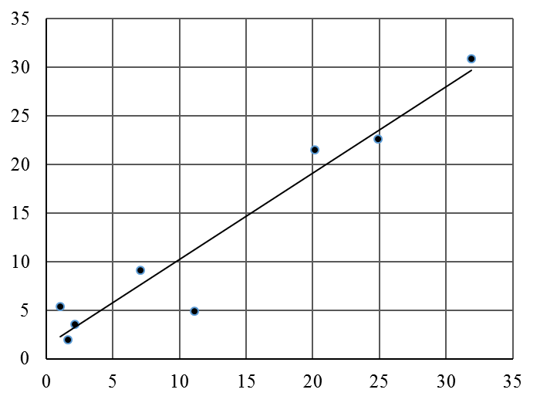
% GST received
✓✓

(f) ✓✓

% of Australian population
✓

✓

(4)

(c) Linear, positive correlation. Strong relationship. (3)
✓ ✓ ✓
(d) 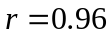 ✓✓ (2)

(e) 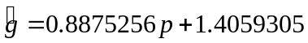 ✓✓✓ (3)

(f) Trend line on graph. ✓✓ (2)

(g) r > 0 and gradient is > 0.
As x increases, y increases, so gradient has to be positive.
As x increases, y increases, so r has to be positive. ✓✓ (2)

(h) If ✓
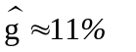✓ (2)

(i) The scatter of the data points about the regression line is random,
so a linear fit is the best fit. ✓✓ (2)

(j) 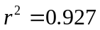 ✓
The unexplained variation between the data isonly 7% ✓
It suggests a very strong linear relationship between the variables. ✓ (3)

(k) (i) = 0.96, so a really strong correlation. ✓
The unexplained variation between the data is 7%. ✓
There is a strong positive relationship between the two variables. (3)
✓

(ii) No, the results do not support the conjecture in the sense the relationship is
very strong.
But the predicted % WA should get of the GST is greater than 11% and is
currently only 4.9%. The discrepancy between the predicted score and the
actual score, and the fact that the correlation is very high suggests that WA is
an outlier. This supports the conjecture. ✓ ✓ (2)

Anything sensible

END OF SECTION TWO

